TEACHING ENGLISH BY USING 2013 CURRICULUM AT SMAN 3 JAMBITHESIS

Submitted as Partial Fulfillment for the Requirements to Obtain the Degreeof Sarjana Pendidikan in English Study Program

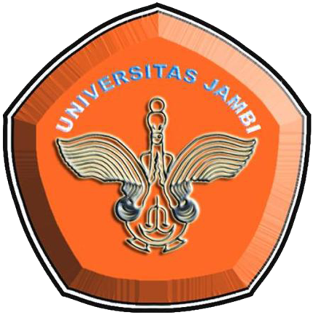

Written by: Ade Arlin RamadhintaRRA1B214034

ENGLISH STUDY PROGRAMLANGUAGE AND ART DEPARTMENTFACULTY OF TEACHER TRAINING AND EDUCATIONJAMBI UNIVERSITY2019