THE THIRD YEAR STUDENTS’ MOTIVATION FOR CHOOSING ENGLISH STUDY PROGRAM AT JAMBI UNIVERSITY : A SURVEY STUDY

A THESIS
Submitted as Partial Fulfillment of the Requirements to Obtain the Degree of Sarjana Pendidikan in English Education Program
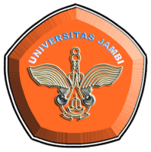

Written by:
DWI LARASATI
RRA1B212003

ENGLISH EDUCATION STUDY PROGRAM
LANGUAGE AND ARTS DEPARTMENT
FACULTY OF TEACHER TRAINING AND EDUCATION
UNIVERSITY OF JAMBI
2019

