**THE PURPOSE OF READING ENGLISH OF FIFTH SEMESTER STUDENTS OF *PGMIPA-U* BIOLOGY IN JAMBI UNIVERSITY**

**A THESIS**

**Submit as a Partial of the Requirements**

**to Obtain the Degree of Sarjana Pendidikan in English Education Program**

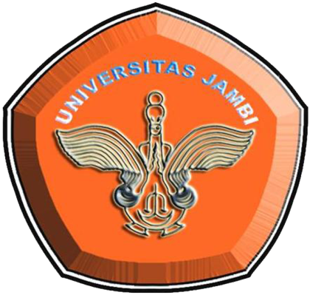

**Written by:**

IRIANY FADILLAH

RRA1B212027

**ENGLISH EDUCATION STUDY PROGRAM**

**LANGUAGE AND ARTS DEPARTMENT**

**FACULTY OF TEACHER TRAINING AND EDUCATION**

**JAMBI UNIVERSITY**

**OKTOBER 2019**